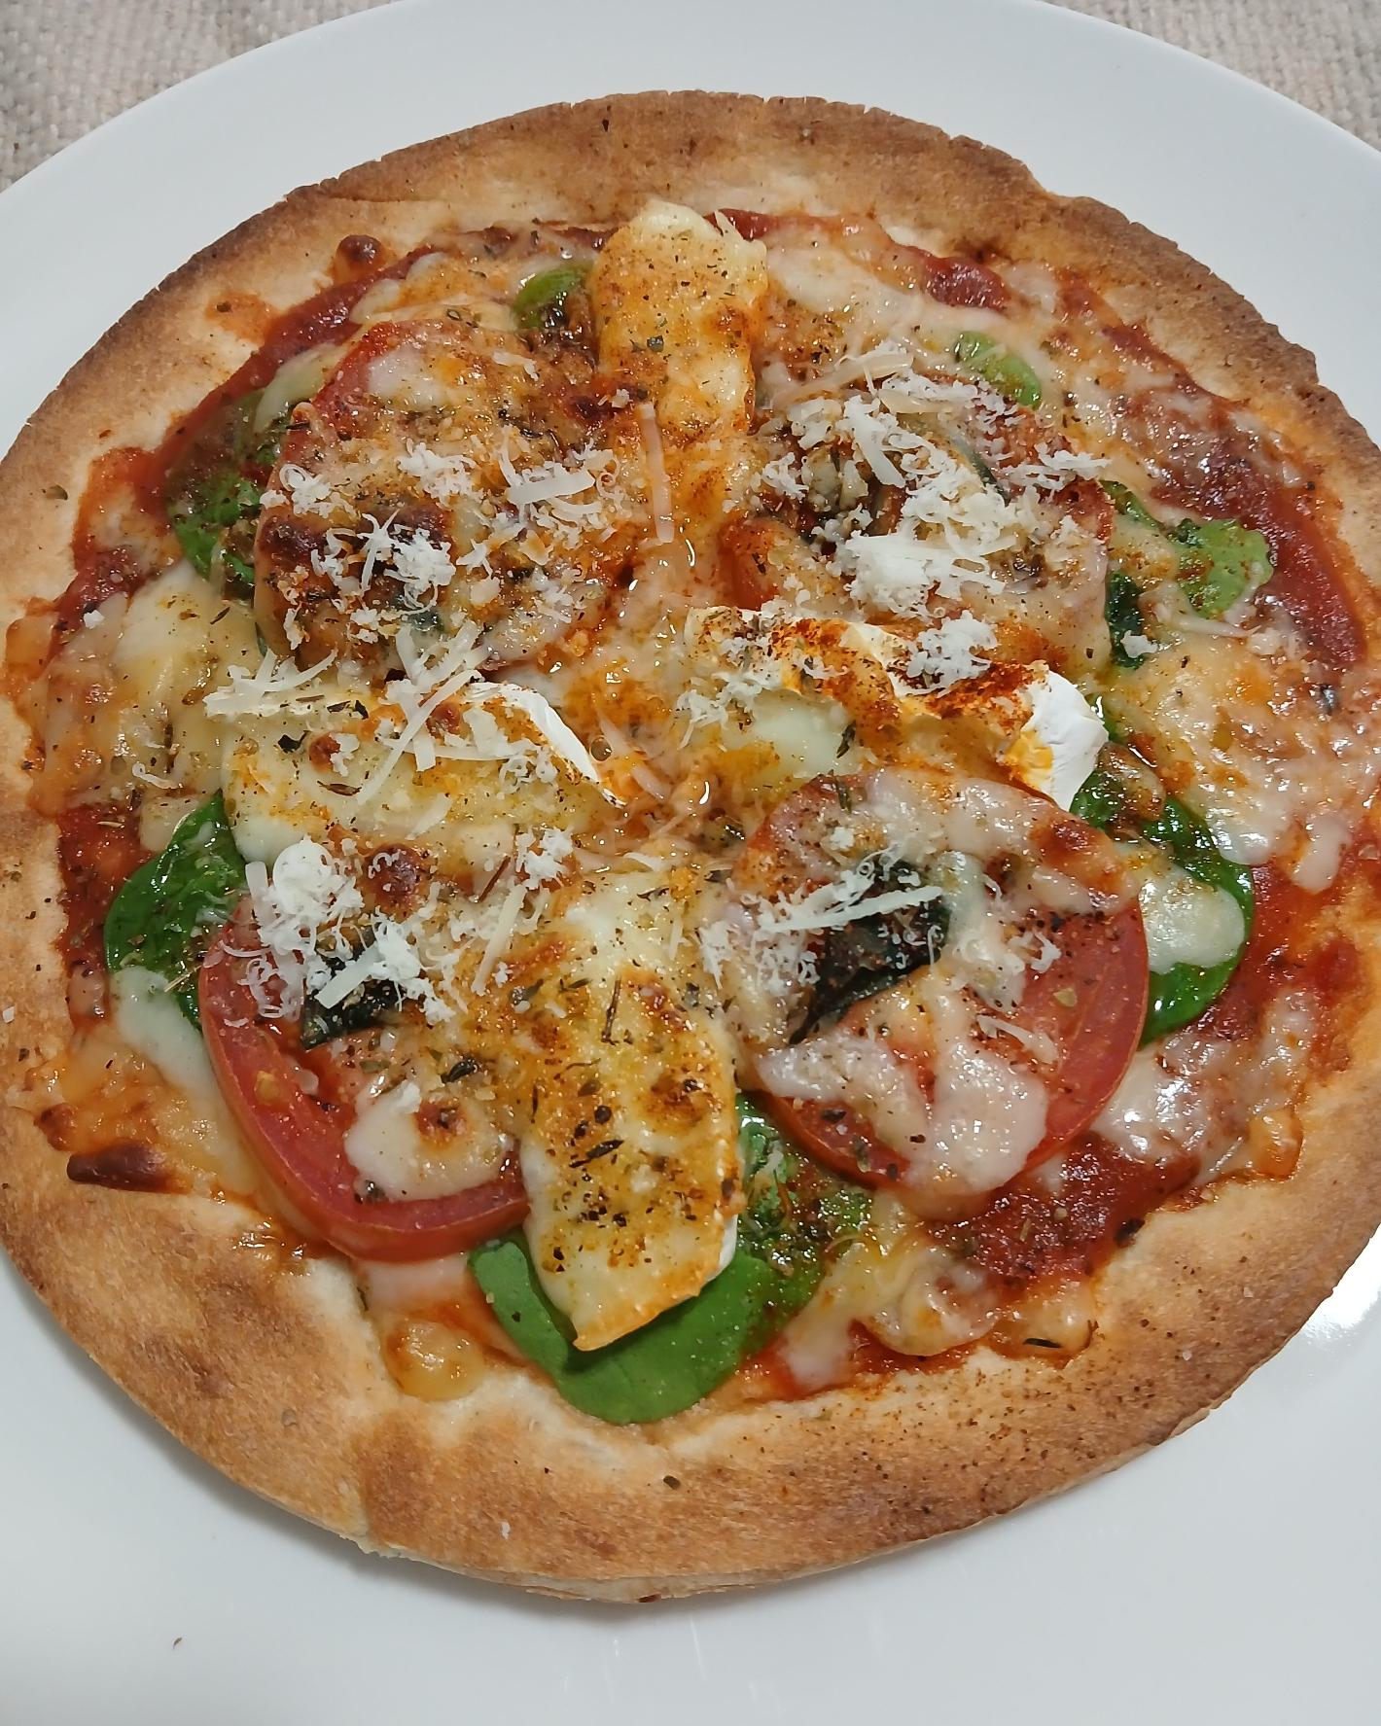

|  |  |  |
| --- | --- | --- |
| Friday Night  Pizza  YOUR GUIDE TO MAKING A GREAT PIZZA |  | MARCH/2024/ISSUE #01 |
|  |  |  |
| Ready to make! By Moriah J. Rogan  This is one of my best go to pizza on Friday. It is full of flavor with. Now I prefer the toaster oven it melts the cheese and warms the pizza nicely. |  | what you need |
| Pizza Crust  The grocery store pre made, I prefer the small ones as well.  topping  Tomato, spinach, parmesan cheese, gouda cheese  pizza sauce  Season your sauce with your likings! |